Job Title: Human Resources Administrator
Team: Human Resources
Base Location: Bradley
Line Manager: Human Resources Manager
Hours of Work: 37.5 hours per week
Staff Group: Corporate
DBS Check – Level Required: None
Vaccination Requirement Statement:
Covid19 double vaccination not required but recommended.
This job has been rated as Low Risk for requiring Hepatitis B immunisation.
Flu jab recommended and will be offered.
Organisation Chart:

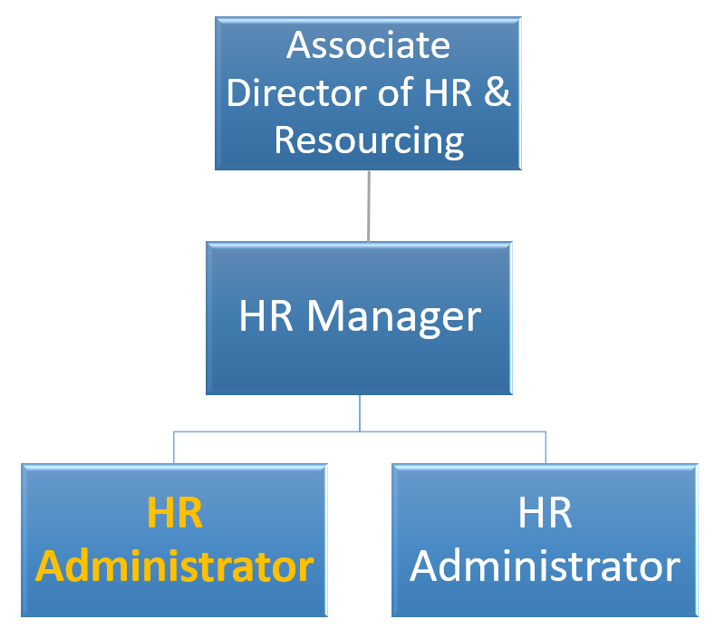

Job Purpose:
To support all HR administrative activity ensuring that a professional approach is taken to all HR administrative functions, ensuring that all processes work effectively.
To work in a small busy HR team, where the culture is fast paced and needs someone who can work in a pressurised environment, who can think on their feet and use their initiative.
Key responsibilities
- To provide administrative support to the HR team with internal processes, in accordance with LCD policies and procedures.
- To support the recruitment and on-boarding process from authorisation, advertising, arranging interviews, carrying out pre-employment checks and processing all new starter administration.
- To assist with updating and maintaining internal HR administration systems relating to probation, performance & development reviews, sick absence management, professional registration checks etc.
- To assist with input of information onto the electronic staff record system and set up and maintain staff files in line with departmental standards and deadlines, and with due regard to confidentiality.
- To assist in reviewing and updating all internal HR systems and processes so that they are up to date and used accordingly.
- Act as first point of contact for general HR queries via email, phone and in person.
- To provide assistance and support to the HR team with the day to day administration of the Pension Scheme for employed staff.
- To Produce ID badges for all new employees.
- To promote and demonstrate best practice at all times
Team
- To ensure adherence to legal, professional and organisational standards, policies and protocols in relation to HR processes.
- To work effectively as part of the HR team and promote and encourage an efficient and professional working environment.
- To act in a manner which is consistent with organisational values.
Communications & Relationships
- To promote effective cross-functional working and support the achievement of objectives, standards and protocols of other directorates.
- Maintain a high profile of Local Care Direct throughout all communications.
- Be responsible for building good relationships with both internal and external customers.
- Communicate effectively within the team.
- Be sensitive to the needs of colleagues.
- Provide information in an accurate and timely way.
Organisational
- To uphold and promote Local Care Direct values and ensure these are translated into working practices and service design.
- To maintain the highest standards of conduct.
- To ensure that the quality of patient care and experience is firmly at the centre of contact centre activities.
- Contribute to the development of the organisation and ensuring it remains fit for purpose at all times.
Personal Development
- Attend mandatory and refresher training sessions / undertake e-learning as required.
- To actively participate in the Performance Development Review process.
- To maintain a Personal development Plan.
Health, safety and security
- It is the individuals’ responsibility for the health and safety of themselves and their surrounding environment.
- To ensure adherence to Health and Safety Policy and guidelines at all times.
COMMUNICATIONS & RELATIONSHIPS
- To ensure agreed lines of communication and reporting are implemented within the team to support all employees understanding LCD business plans, objectives, priorities and changes.

- To promote effective cross-functional working and that the operational team supports the achievement of objectives, standards and protocols of other LCD areas.

- To attend internal and external meetings representing LCD and engaging in discussions appropriate to the role and level of the post.

PATIENT CARE

To ensure that the quality of patient care is firmly at the centre of the organisation’s objectives and vision.
To ensure the management and monitoring of the highest standards or safety and quality in the delivery of healthcare and related services, and manage risk within Local Care Direct.

FINANCIAL RESOURCES

To ensure financial policies and procedures are maintained and the budget is adhered to and that best value for money is achieved.

CONFIDENTIALITY

To operate and ensure the team operates within information governance protocols and that business confidentiality is maintained at all times.

TRAINING

To complete the defined company induction programme and core training for this role and mandatory refresher training thereafter and ensure that accurate records of training are maintained.

INFECTION PREVENTION AND CONTROL

Healthcare workers have a duty of care to patients and are expected to comply fully with the companies Infection Prevention and Control (IP&C) policies and attend/complete IP&C training, for personal and patient safety and for prevention of healthcare-associated infection (HCAI). Knowledge, skills and behaviour in the workplace should reflect this.

SAFEGUARDING

Individuals have a duty of care to children and vulnerable adults that they come into contact with whilst at work to safeguard and promote their welfare and to work to prevent, recognise, respond, appropriately refer and record potential neglect or abuse, adhering to the company’s Safeguarding Children and Safeguarding Vulnerable Adults policies and procedures.

MANAGING SELF

Ensure that relevant professional practice is evidence based and current.
Ensure that continual professional development is maintained and facilitates the ability to provide care to a high standard in a way that is both safe and cost effective.
Ensure that mandatory training is up to date and participate in training as appropriate.
Effectively utilise time management, organisational, co-ordination and – if required - management skills.
Identify own professional development needs through the Personal Development Review process (PDR).
The main duties and responsibilities shown here are not exhaustive and the postholder will be expected to carry out any reasonable activities according to the needs of the business as directed by the line manager.
PERSON SPECIFICATION
The successful performance of this role will require some flexible working hours and will be expected to operate at a satisfactory level (to be agreed with line manager) to specific LCD leadership competencies (set out below) and to maintain a personal development plan to address development needs.
 | Essential | Assessment
Qualifications | Level 4 English (GCSE Grade C or equivalent) | Application
Experience | Administrative experience in a busy, customer-focused environment. | Application & Assessment
Skills | Excellent written and verbal communication and interpersonal skills, able to deal confidently with managers and staff at all levels.  Good organisational and prioritisation skills.  The ability to work accurately, with attention to detail.  Ability to meet challenging targets.  Strong team-working skills to support HR team members in delivering an effective HR service.  Professional and confidential approach to responsibilities.  Able to anticipate wider consequences of decisions and know when to refer upwards.  Ability to adopt a structured approach, understand the need for, and to follow, systems and processes.  The ability to work under pressure.  Ability to plan and prioritise a diverse and variable workload.  Excellent IT skills – Office packages (word, excel etc) | Application & Assessment
Knowledge | Experience of dealing with a wide and diverse range of administrative issues | Application & Assessment
 | Desirable |  | Assessment
Qualifications | Level 4 and above in English and Maths (GCSE Grade C or Equivalent) |  | Application
Knowledge | Up to date knowledge of employment law and best practice in HR issues  Knowledge and understanding of Pensions, ideally NHS Pension Scheme  Experience of working in a HR function |  | Application

MEASURES OF PERFORMANCE
Performance will be regularly monitored and assessed via monthly review of business performance, personal objectives and delivery against this job and person specification.

JOB DESCRIPTION AGREEMENT
I have read and understood this job and person specification:
Signed Job Holder: | Date
Signed Line Manager: | Date

